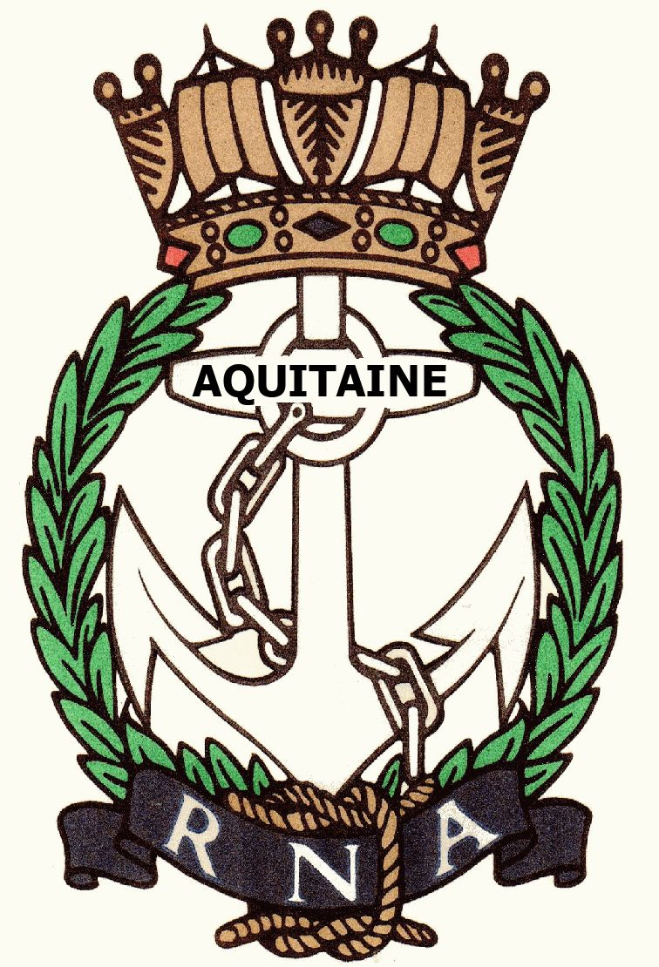
AQUITAINE BRANCH – ROYAL NAVAL ASSOCIATION
404 Impasse de Chazarem, 47290 Beaugas
napier.chazarem@wanadoo.fr www.rna-aquitaine.com Tel 05 53 01 72 80

Minutes of Annual General Meeting held at Le Semillon, Monbazillac, on Wednesday 12th March 2025

- PRESENT: Chris Haskell, Lorraine Hatchett, Kevin Hatchett, Mike Holland, Jeannette Kastelein, Ken Napier, Sue Napier, Bill Oliphant

- APOLOGIES: Dennis Andrews, Chris Barnacle, Valerie Clarke, Steve Collins, Hazel Door, Martin Door, Michael Finzel, David Forsyth, Valerie Heath, Antoinette Henry, Marion Hirst, Tony Hirst, John Larmuth, Angela Larmuth, David Rollston-Smith, Patrick Sturges, Greta Tow

- APPROVAL OF MINUTES OF LAST AGM: The minutes were approved Proposed Chris Haskell, seconded Mike Holland

- ELECTION OF COMMITTEE: The existing committee of : Chairman Ken Napier, Secretary Sue Napier, Treasurer Chris Haskell, Welfare Lorraine Hatchett, Webmaster Brian Johnson was unanimously re-elected Proposed Bill Oliphant, Seconded Mike Holland

- CHAIRMAN’S REPORT: Ken started by saying we were now back to normal after the covid hiatus and that we were 31 full members and 12 associates as of 31st December 2024. Average lunch attendance is 15, but lower numbers make it easier to find restaurants. The best attended lunch was the Trafalgar lunch. He pointed out we had made donations last year to RNA, RNBT, WRNSBT, ARNO and SSAFA. He also said that he and Sue had maintained contact over lunches with some of our French counterparts in the AMMACS of Bergerac and Fumel. He concluded by thanking Chris, Sue, Lorraine and Brian for their work over the last 12 months.

- TREASURER’S REPORT: Chris started by saying that funds are healthy but that our income is only from subs paid and the monthly raffle that we hold at the lunches. The lunches themselves should stand alone. There was a small surplus this year due to 2 restaurants charging less than originally stated! The 300€ marked in red on the credits is due to the cheque sent to WRNSBT last year, being presented in UK, paid in UK but never making it back to France! Our bank balance stands at 3200€ with 190€ in cash.

- ALLOCATION OF FUNDS: It was initially decided to follow the previous year’s allocation of 300€ to each of the 5 charities but Bill Oliphant then explained that the WRNSBT and ARNO finances are now managed by the RNRMC (Royal Naval Royal Marine Charity.) He explained that the WRNSBT is very well off financially, with a shrinking pool of people needing to use it. (Current female RN personnel come under the RNBT.) He proposed that we give 400€ each to the RNA, RNBT, RNRMC and SSAFA. This was agreed unanimously by the members present proposed seconded by Lorraine and Kevin Hatchett.

- MEMBERSHIP: It was pointed out that we had already gained one new member this year with a possible second, 2 former members had opted not to rejoin and 2 had crossed the bar in 2024.

- SOCIAL PROGRAMME: The date for the Trafalgar lunch was fixed for Wednesday October 15th 2025 and will be at Le Semillon in Monbazillac. Bill Oliphant has undertaken to try to find us a speaker.

- ANY OTHER BUSINESS: Bill announced that the Annual Conference would be held in Portsmouth over the weekend of 20/21/22 June 2025. Anyone interested in attending would have their travel paid for by HQ. The meeting closed at 11.26

